Entry level, previous generation models, and sometimes two generations previous models (m4/3 + APS-C) are priced at $400-700 for camera body + kit lens, sometimes with 2 lenses.

A few examples from B&H (Nov. 8, 2019):
- Nikon D3500 + 18-55mm lens $400
- Canon EOS Reel T7 + 18-55mm lens $400
- Fujifilm X-A10 + 16-50mm lens $329
- Fujifilm X-T100 + 15-45mm lens $500
- Canon EOS M100 + 15-45mm lens $500
- Sony a6000 + 16-50mm lens $548
- Pentax K-70 + 18-55mm lens $647
- Olympus OM-D E-M10 + 14-42mm lens $499
- Panasonic Lumix G7 + 14-42mm & 45-150mm $746

- Sony A7 Mark II + 28-70mm lens $998 (FF mirrorless, current A7 is Mark IV)

- Nikon D750 + 24-120mm lens $1700 (FF DSLR)

- Canon EOS RP + 24-240mm lens $1500 (FF mirrorless)

- Canon EOS 6D + 24-105mm lens $1599 (FF DSLR)

BEGINNER’S CORNER
November 2019by Timothy Kant
for the Wehr Nature Center Camera Club
==================================================
BLACK FRIDAY SALES are going on already.
WHICH CAMERA SHOULD I BUY?
The truth is:
You can shoot great photos with any camera on the market today.A smartphone camera is always with you and is good enough for many … but if you want a camera with interchangeable lenses …
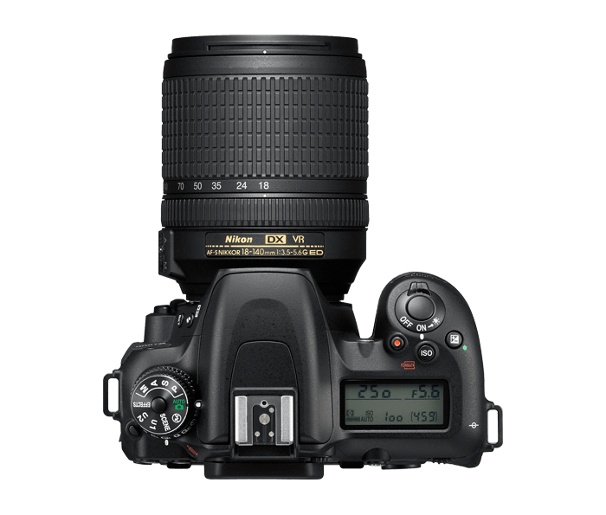

Decision #1 – What is your budget?
$ = Refurbished/Used
$$ = Micro 4/3 and APS-C
$$$ = Full Frame
Decision #2 – What sensor size?
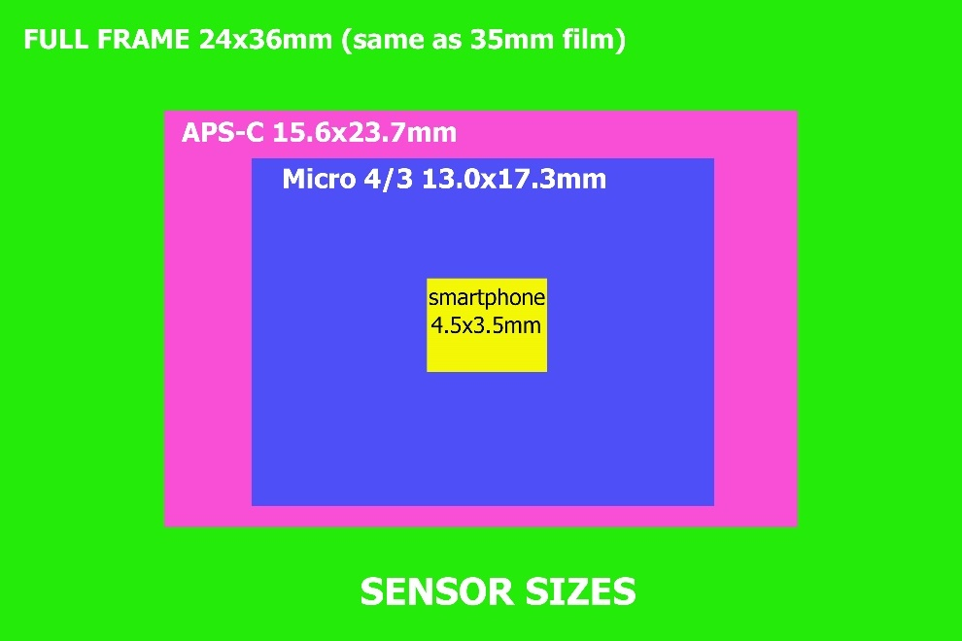
A bigger sensor gathers more light.
A smaller sensor costs less, enables smaller camera.
A bigger sensor enables very shallow depth of field. A smaller sensor gives more DOF with the same lens.
FF = f2.8 FF = f1.4
APS-C = f2.0 APS-C = NA
m4/3 = f1.4 m4/3 = NA

Crop Factor: Sensor size changes angle of view.
FF (CF =1.0x) 50mm lens
APS-C (CF = 1.5x) 50mm lens give angle of view like a 75mm
m4/3 (CF = 2.0x) 50mm lens gives angle of view like a 100mm
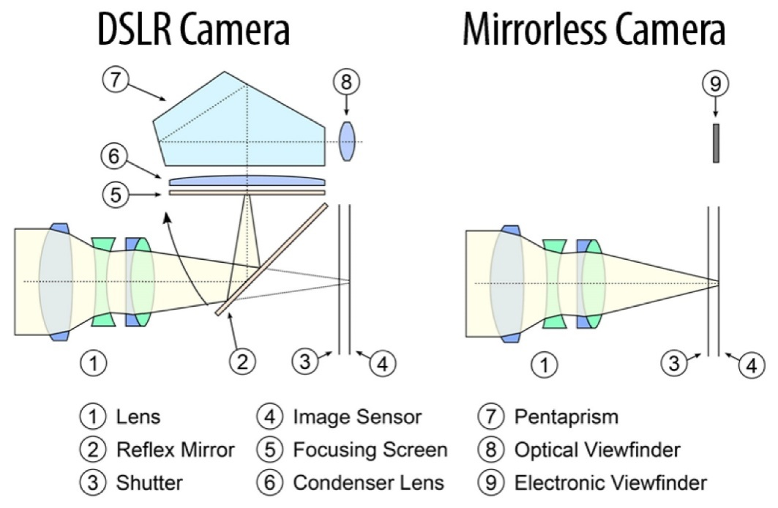
Decision #3 – Which camera design? DSLR or Mirrorless

Sony: All models are mirrorless (FF + APS-C)
Fujifilm: All models are mirrorless (APS-C + medium format)
Olympus & Panasonic: All models are mirrorless (m4/3)
Canon/Nikon: Transitioning from DSLR to Mirrorless (FF + APS-C)
Pentax: DSLR (APS-C) ??

